Agreement Requests Mass Approval Process:
The document Elaborates the Mass approval process of agreement requests in Vistex application.
Required setup:
Agreement Requests must be created prior to perform Mass approval.

Mass Approval of Master Requests.

Initial Approval:
- Off Invoice Rebates Mass Request approvals (tile)
- Click on Go.
- Select required requests to be approved (Maximum of 50) and click on approval (above of Worklist)
Note Points:
- Make sure you approve requests related to respective users only.
- Requests to two different statuses cannot be approved in one selection
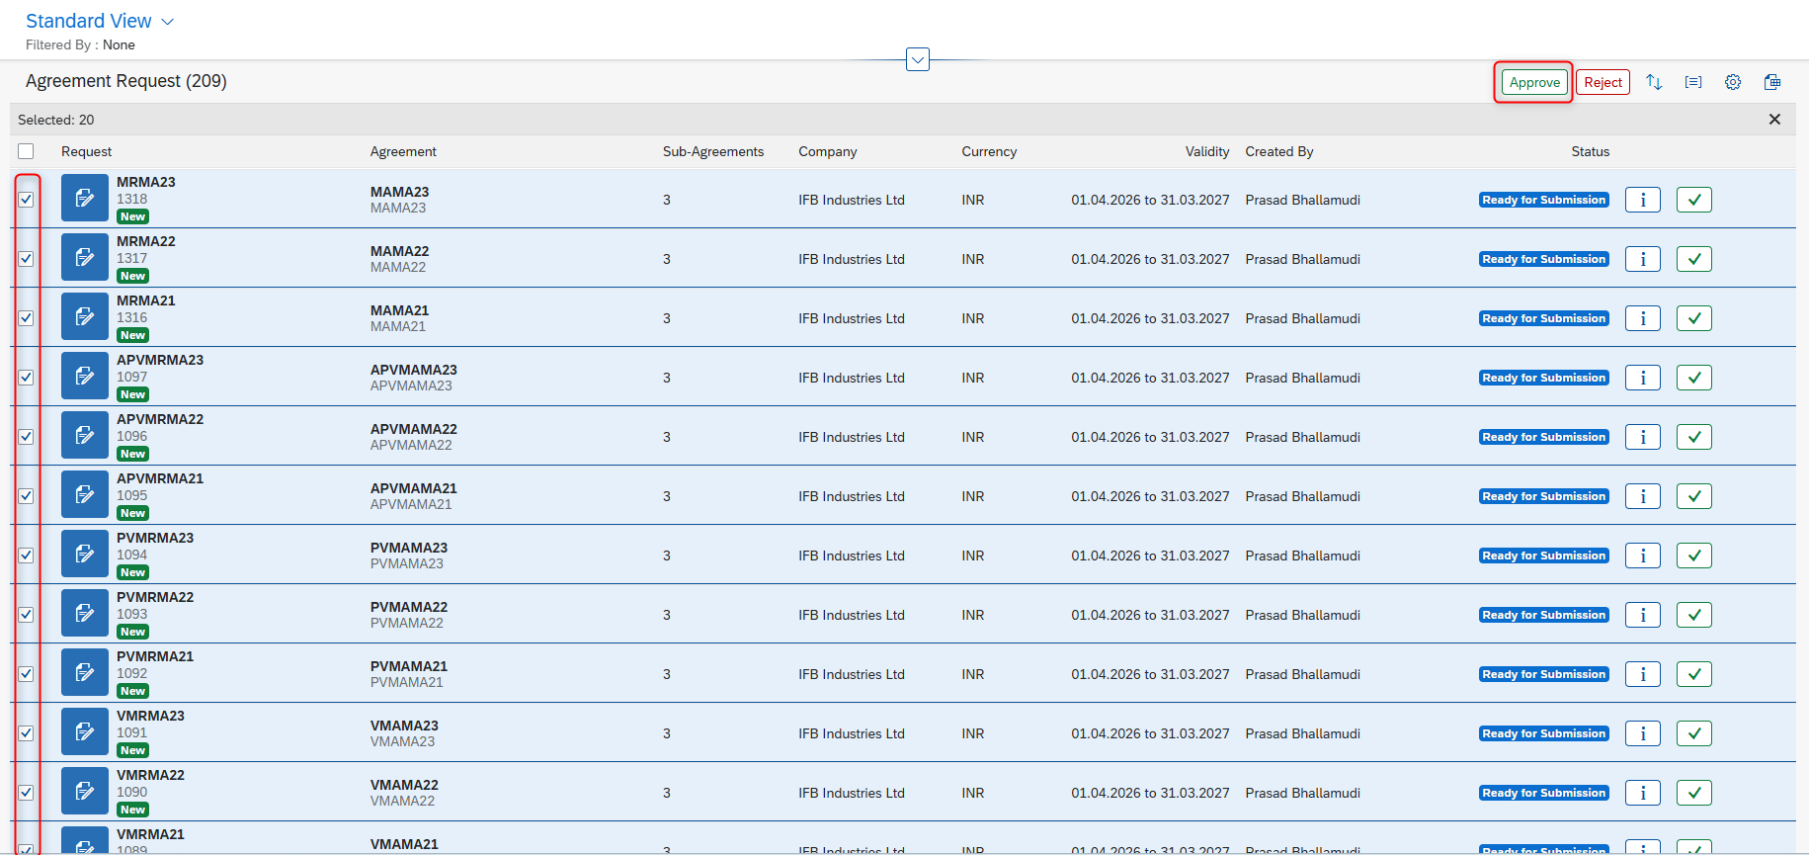
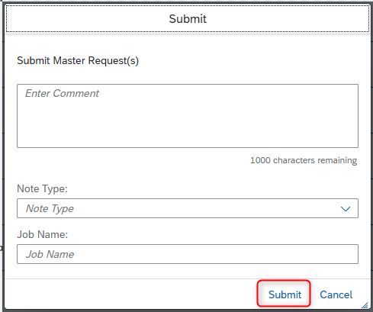
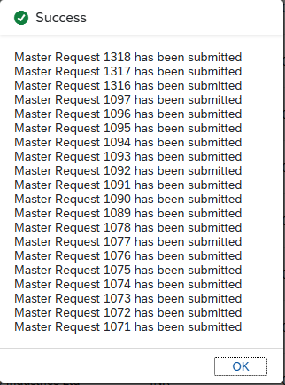

Regional Accounting Approval
After verifying, the regional accounting user will select required agreement requests and click on Approve button.
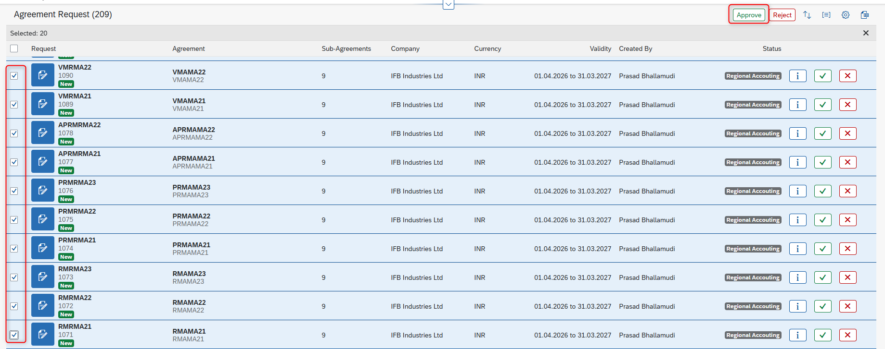
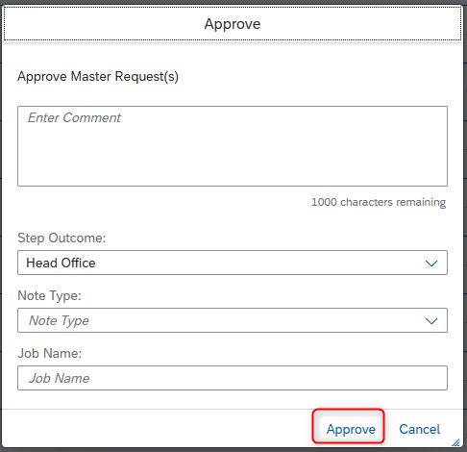
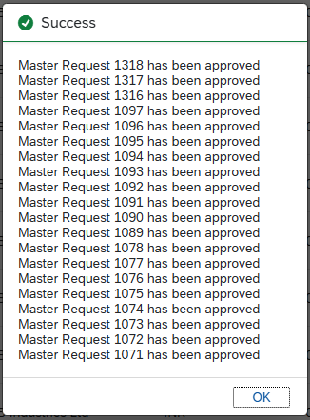

Head Office Approval:
After verifying, the head office user will select required agreement requests and click on Approve button.
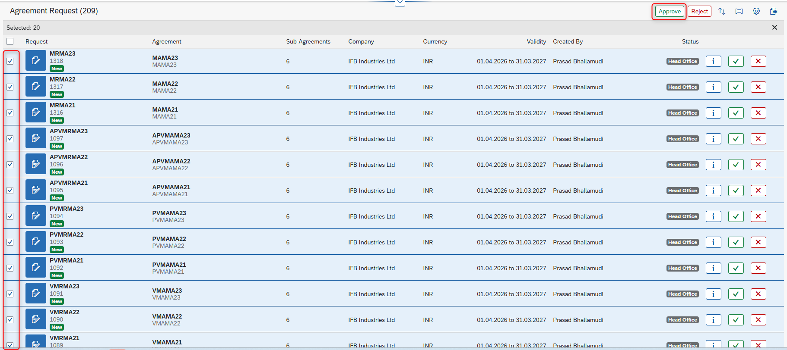
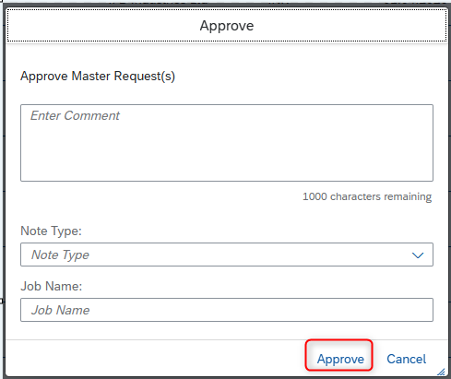
After final approval, the approved requests will be removed from approval list.
The Master agreements has to be verified in Master agreements Tile.

